Barclays EPDQ 3D Secure 2

Advanced
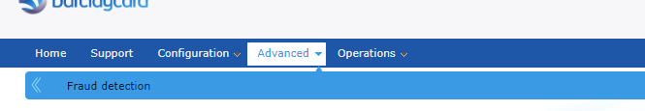
- Open the ‘Advanced’ option from the top menu, open the ‘Fraud Protection’ sub menu
Ensure that the 3-D Secure status is ‘Active’ for each of your active card types
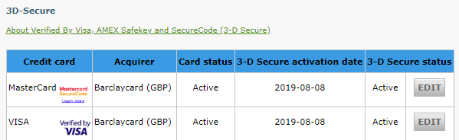

Configuration
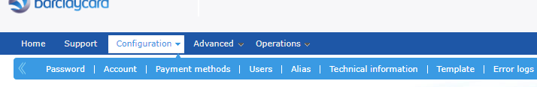
- Open the ‘Configuration’ option from the top menu, open the ‘Users’ sub menu
Check that the User ID and Password stored in your accessplanit system (in your Barclays EPDQ settings in the Account Finance Options page) match to an API user configured as a user in this page.

- Open the ‘Configuration’ option from the menu, open the ‘Technical Information’ sub menu, open the ‘Global security parameters’ option, set the Hash algorithm to SHA-1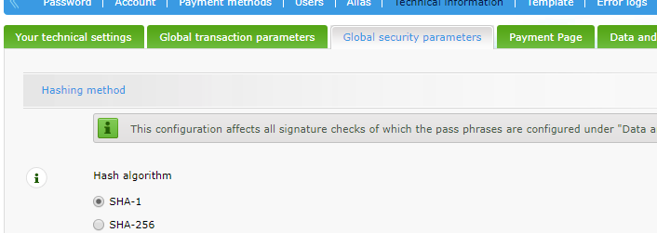
- Open the ‘Configuration’ option from the top menu, open the ‘Technical Information’ sub menu, open the ‘Data and origin verification’ menu option
  - Find the SHA-IN pass phrase, this should match the SHA-IN pass phrase stored in your accessplanit system (in your Barclays EPDQ settings in the Account Finance Options page)
  - Find the IP address, this should contain the IP address of your accessplanit system (speak to the helpdesk team at accessplanit if you do not know this)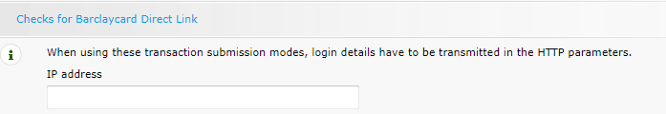
- Open the ‘Configuration’ option from the top menu, open the ‘Technical Information’ sub menu, open the ‘Transaction Feedback’ menu option
  - Find the SHA-OUT pass phrase (within the ‘All transaction submission modes’ section), this should match the SHA-IN pass phrase stored in your accessplanit system (in your Barclays EPDQ settings in the Account Finance Options page)
  - Find the option ‘I would like to receive transaction feedback parameters on the redirection URLs.’ ensure that this option is ticked.
Checking this option will set the SHA-OUT pass phrase covered in #5a as mandatory.
  - Find the section ‘Direct HTTP server-to-server request’
The two URLs within this section must match to the accessplanit provided URLs in your Barclays EPDQ settings in the Account Finance Options page
- If the payment's status is "accepted", "on hold" or "uncertain". = Transaction Feedback/Post URL
- If the payment's status is "cancelled by the client" or "too many rejections by the acquirer" = Allowed Url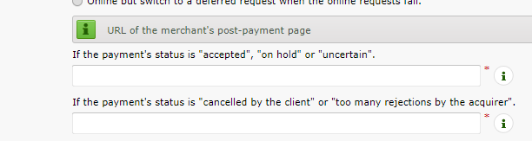

Please note that Barclays request that you use different SHA pass phrases in your test site and your live site. If you do set them to be the same, Barclays will update them to be different and notify you.

